20MCA241-Data Science Lab A

1. The number of absentees in class VIII was recorded in a particular week. Represent this data on the bar graph
(i) Create a line graph with appropriate Labels and title
(ii) Use blue line color with style dotted
(iii) Points represented in yellow color and diamond shape
Days | Mon. | Tues. | Wed. | Thurs. | Fri. | Sat.
Number of Absentees | 130 | 120 | 135 | 130 | 150 | 80
Code

import matplotlib
import matplotlib.pyplot as plt
import numpy as np
plt.title("Record of Absentees")
plt.xlabel("Days",size=10)
plt.ylabel("Number of Absentees")

x = np.array(['mon','Tues','wed','Thurs','fri','sat'])
y = np.array([130,120,135,130,150,80])
plt.scatter(x, y,color = 'yellow')

output
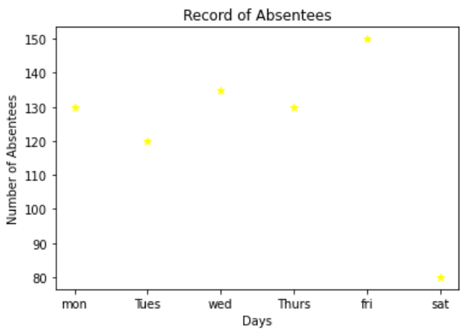
2. Program to print first n prime numbers

code
import math
def is_prime(n):
ans = False
for i in range(2, int(math.sqrt(n)) + 1):
if n % i == 0:
ans = True
return ans
print("prime numbers between 1 to 10:")
for x in filter(is_prime, range(1, 11)):
print(x)

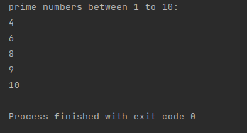
output

